Experiment no-4
Online Train Reservation System
AIM:
To develop an online train reservation website using HTML, CSS, and JavaScript to search trains and check seat availability. The system allows users to reserve tickets, check PNR status, cancel tickets, and view refunds.
Procedure:
- Create a train search form using HTML.
- Apply CSS to design the interface.
- Use JavaScript to collect journey details.
- Display a sample reservation confirmation.
- Test the webpage in a browser.
Sample Code:
<!DOCTYPE html>
<html>
<body>
<h2>Train Reservation</h2>
<input id="from" placeholder="Source Station">
<input id="to" placeholder="Destination Station">
<button onclick="reserve()">Reserve Ticket</button>
<p id="result"></p>
<script>
function reserve() {
let f = document.getElementById("from").value;
let t = document.getElementById("to").value;
if (f && t && f.toLowerCase() !== t.toLowerCase()) {
document.getElementById("result").innerHTML =
"Reservation request: " + f + " to " + t;
} else {
document.getElementById("result").innerHTML =
"Enter valid station details";
}
}
</script>
</body>
</html>
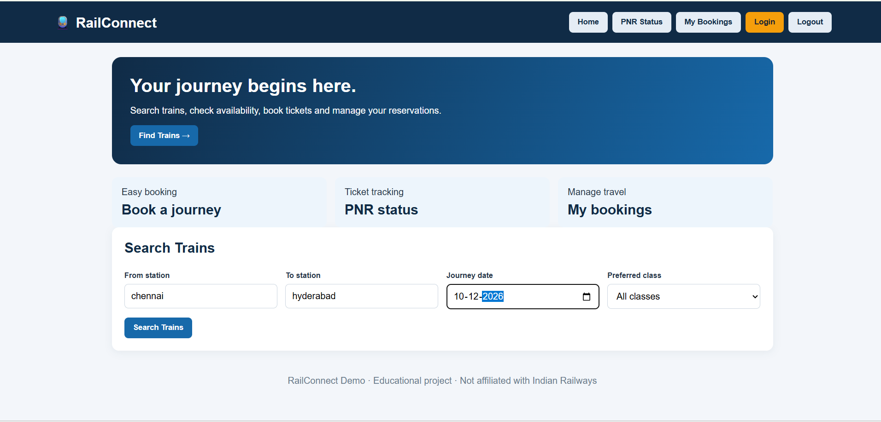
Result:
Thus, the train reservation website was developed successfully to search trains, check seat availability, reserve tickets, check PNR status, and manage cancellations.

